**Topic: Quality of Life after COVID-19**

**Questionnaire:**

***This information/question were obtained from:***

***https://cccse.org/sites/default/files/2020_COVID-19_Spring_Item_Set.pdf***

***please indicate how concerned you are at this time about the following***

**44. What is your gender?**

**a. Man**

**b. Woman**

**c. Other**

**d. I prefer not to respond**

**45. What is your age?**

**a. Younger than 18**

**b. 18–19**

**c. 20–21**

**d. 22–24**

**e. 25–29**

**f. 30–39**

**g. 40–49**

**h. 50–65**

**i. Older than 65**

**30. Access to health care**

**a. Very concerned**

**b. Somewhat concerned**

**c. Slightly concerned**

**d. Not at all concerned**

**31. Access to mental health services**

**a. Very concerned**

**b. Somewhat concerned**

**c. Slightly concerned**

**d. Not at all concerned**

**32. Having enough food for myself and/or my family**

**a. Very concerned**

**b. Somewhat concerned**

**c. Slightly concerned**

**d. Not at all concerned**

**33. Having a safe and secure place to live/sleep at night**

**a. Very concerned**

**b. Somewhat concerned**

**c. Slightly concerned**

**d. Not at all concerned**

**34. Paying for my education**

**a. Very concerned**

**b. Somewhat concerned**

**c. Slightly concerned**

**d. Not at all concerned**

**35. Paying utility bills**

**a. Very concerned**

**b. Somewhat concerned**

**c. Slightly concerned**

**d. Not at all concerned**

**36. Paying rent or mortgage**

**a. Very concerned**

**b. Somewhat concerned**

**c. Slightly concerned**

**d. Not at all concerned**

**38. Feeling isolated**

**a. Very concerned**

**b. Somewhat concerned**

**c. Slightly concerned**

**d. Not at all concerned**

**40. Which of the following formats do you prefer?**

**a. In-class only**

**b. Online only**

**c. Classes with both in-class and online components**

**41. Has the COVID-19 pandemic caused you to think about changing your chosen major, program, or pathway of study?**

**a. Yes, I am considering changing**

**b. Yes, but I have decided not to change**

**c. No**

**d. I have not chosen a major, program, or pathway of study**

**4. Which of the following currently present challenges for fully engaging in online courses? (Mark all that apply.)**

**a. Access to a reliable computer or laptop**

**b. Access to a reliable smartphone or tablet**

**c. Access to reliable internet at home**

**d. Having enough time to study**

**e. Caring for family members**

**f. Working from home makes it difficult to separate work and school g. Working at my regular physical place of work**

**() Smoking Status**

1. **Never smoked**
2. **Current smoker**
3. **Past smoker**

**() Chronic diseases**

1. **Hypertension**
2. **Diabetes**
3. **Asthma / COPD**
4. **Heart disease**
5. **Chronic kidney disease**
6. **Cancer**
7. **Other diseases**

**() Residence**

1. **Rural**
2. **Urban**
3. **Semi-urban**

**() Employment status**

1. **Unemployed**
2. **Employed**
3. **Others**

**() Health care worker**

1. **Yes**
2. **No**

**() Educational status**

**() Monthly family income in BDT / USD**

**() Admission to hospital due to COVID-19**

1. **Yes**
2. **No**

**() Dietary habit**

**() Physical exercise**

**() Alcohol**

**These following questions were inspired by a journal by:**

**Kumari, A., Ranjan, P., Vikram, N. K., Kaur, D., Sahu, A., Dwivedi, S. N., Baitha, U., & Goel, A. (2020). A short questionnaire to assess changes in lifestyle-related behaviour during COVID 19 pandemic. Diabetes & metabolic syndrome, 14(6), 1697–1701. [https://doi](https://doi/).org/10.1016/j.dsx.2020.08.020**

**How has your probability of skipping on of the ain meals (breakfast lunch dinner) changed?**

**(b) Slightly increased**

**(c) Grossly similar**

**(d) Slightly decreased**

**(e) Significantly**

**How has your habit of snacking between meals changed?**

**(b) Slightly increased**

**(c) Grossly similar**

**(d) Slightly decreased**

**(e) Significantly**

**How has your quantity/ portions of meals and snacks changed?**

**(b) Slightly increased**

**(c) Grossly similar**

**(d) Slightly decreased**

**(e) Significantly**

**How has your daily intake of fruits and vegitables changed**

**(b) Slightly increased**

**(c) Grossly similar**

**(d) Slightly decreased**

**(e) Significantly**

**How has your intake of a balanced diet (including healthy ingredients such as wheat legumes eggs nuts fruits and vegitables) changed?**

**(b) Slightly increased**

**(c) Grossly similar**

**(d) Slightly decreased**

**(e) Significantly**

**How has your consumption of junk food/fast food and fried food changed?**

**(b) Slightly increased**

**(c) Grossly similar**

**(d) Slightly decreased**

**(e) Significantly**

**How has your intake or sugar-sweetened beverages (carbonated soft drinks, sugar sweetened juices) changed?**

**(b) Slightly increased**

**(c) Grossly similar**

**(d) Slightly decreased**

**(e) Significantly**

**How has your participation in cooking new/traditional recipes changed?**

**(b) Slightly increased**

**(c) Grossly similar**

**(d) Slightly decreased**

**(e) Significantly**

**How has your consumption of sweets/candies/chocolate changed?**

**How has your consumption of unhealthy food when you were bored or stressed or upset changed?**

**(b) Slightly increased**

**(c) Grossly similar**

**(d) Slightly decreased**

**(e) Significantly**

**How has your intake of nutrition supplements to boost immunity changed?**

**how has your intake of immune boosting foods (lemon, turmeric, garlic, citrus fruits and green leafy vegetables) in the diet changed?**

**(b) Slightly increased**

**(c) Grossly similar**

**(d) Slightly decreased**

**(e) Significantly**

**How has your participation in exercise/physical activity changed?**

**(b) Slightly increased**

**(c) Grossly similar**

**(d) Slightly decreased**

**(e) Significantly**

**How has your participation in social activities changed?**

**(b) Slightly increased**

**(c) Grossly similar**

**(d) Slightly decreased**

**(e) Significantly**

**How has your participation in household chores changed?**

**(b) Slightly increased**

**(c) Grossly similar**

**(d) Slightly decreased**

**(e) Significantly**

**How has your sitting and screen time changed?**

**(b) Slightly increased**

**(c) Grossly similar**

**(d) Slightly decreased**

**(e) Significantly**

**How have your hours of sleep changed?**

**(b) Slightly increased**

**(c) Grossly similar**

**(d) Slightly decreased**

**(e) Significantly**

**How has your quality of sleep changed?**

**(b) Slightly increased**

**(c) Grossly similar**

**(d) Slightly decreased**

**(e) Significantly**

**How have your stress and anxiety levels changed?**

**(b) Slightly increased**

**(c) Grossly similar**

**(d) Slightly decreased**

**(e) Significantly**

**(the scoring for this set Items 1, 2, 6, 7, 8, 9∗, 10, 17 and 20 are scored as:**

**2 = Significantly decreased, 1 = Slightly decreased, 0 = Grossly similar, -1 = Slightly increased, -2 = Significantly increased.**

**Items 4, 5, 11, 12, 13, 14, 15, 16 and 19 are scored as:**

**2 = Significantly increased, 1 = Slightly increased, 0 = Grossly similar, -1 = Slightly decreased, -2 = Significantly decreased.**

**Item 3∗∗, 18∗∗∗ is scored as:**

**0 = Grossly similar-1 = Slightly increased/decreased-2 = Significantly increased/decreased**

**∗Item 9 is scored assuming that these recipes are usually high in calories.**

**∗∗Item 3 is scored assuming that the person was having normal portion of meals and snacks before COVID pandemic.**

**∗∗ Item 18 is scored assuming that the individual was having an adequate 6-8 hours sleep before pandemic.**

**Clinicians may use their discretion and modify the scoring on case to case basis.**

**of questions are as followed…**

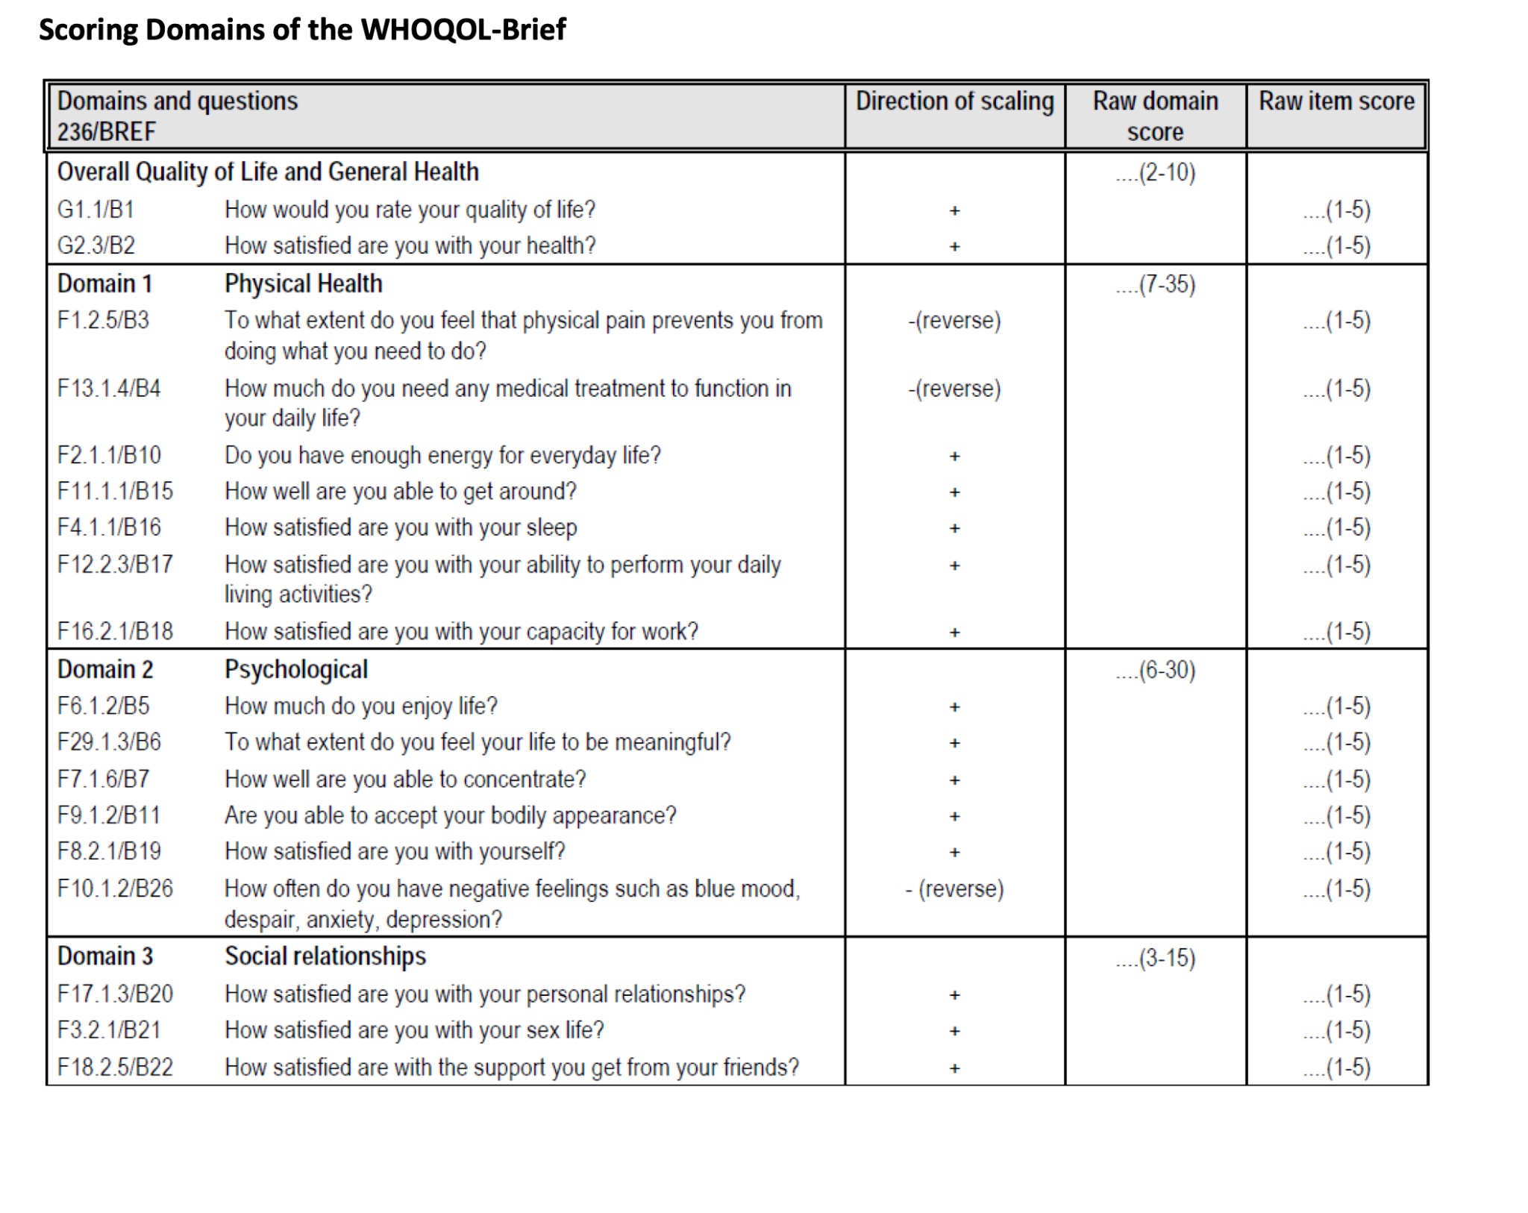

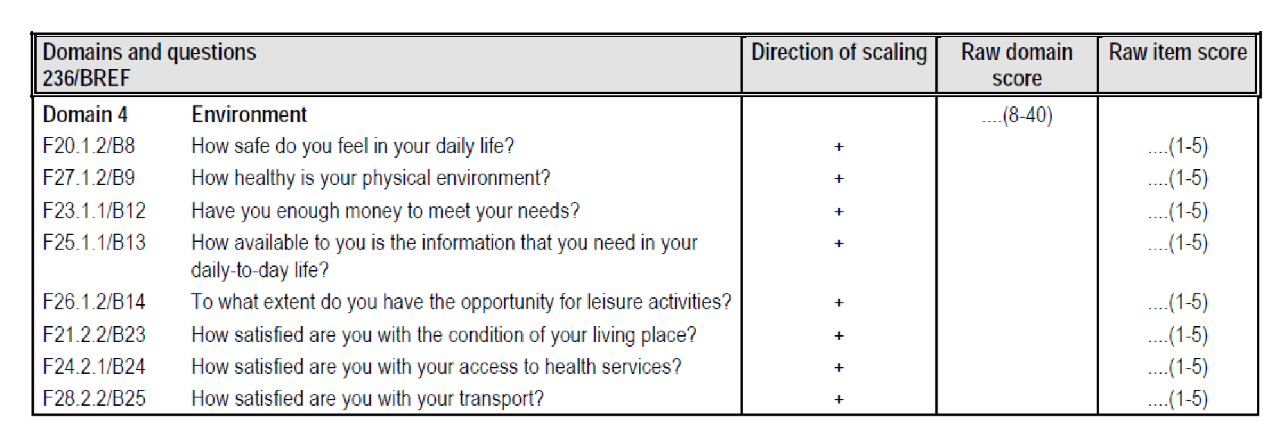

^^^ here are a few more questions that I found that we could either use or re-word and utilize the numerical rating and scoring.

This is from the WHO Quality of Life Scale-Brief –

<https://depts.washington.edu/uwcssc/sites/default/files/hw00/d40/uwcssc/sites/default/files/WHO%20Quality%20of%20Life%20Scale.pdf>

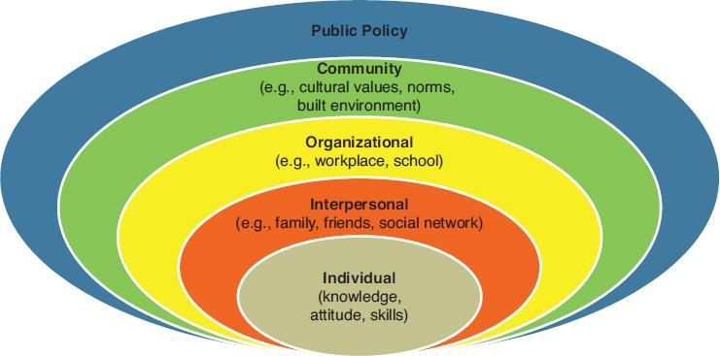

Here is a better Social Ecology Model…. I think the last one that I emailed was too detailed. This one gives a very basic explanation.